State Transition Testing

Definition
# Source: Chatgpt (GPT-5-Standard) at [8/15/2025]
State Transition Testing is a black-box test design technique used when a system’s behavior changes based on its current state and a triggering event (input).
It’s especially useful for systems that act like a finite state machine — meaning, the output depends not only on the input but also on what state the system is currently in.

Key Concepts
# Source: Chatgpt (GPT-5-Standard) at [8/15/2025]
- State → A specific condition or mode of the system at a point in time.
- Transition → A change from one state to another caused by an event or input.
- Event → The action or condition that triggers the transition.
- Action → The output or result after the transition.

Example
# Source: Chatgpt (GPT-5-Standard) at [8/15/2025]
Imagine an ATM:

States:
# Source: Chatgpt (GPT-5-Standard) at [8/15/2025]
- Idle (no card inserted)
- Card Inserted (awaiting PIN)
- Authenticated (ready for transactions)
- Card Ejected (back to idle)

Transitions:
# Source: Chatgpt (GPT-5-Standard) at [8/15/2025]
- Insert card → Idle → Card Inserted
- Enter correct PIN → Card Inserted → Authenticated
- Enter wrong PIN 3 times → Card Inserted → Card Ejected
- Withdraw money → Authenticated → Authenticated (same state)
- Press cancel → Any state → Card Ejected

State Transition Diagram
# Source: Chatgpt (GPT-5-Standard) at [8/15/2025]
A State Transition Diagram is a visual representation of how a system moves between different states based on events, inputs, or conditions.
It shows:
- States → The different situations or modes the system can be in.
- Transitions → The changes from one state to another when an event occurs.
- Events/Triggers → Actions or inputs that cause a transition.
- Guards/Conditions → Rules that must be true for the transition to happen.
- Actions → The operations performed when the transition occurs.

Key Elements
# Source: Chatgpt (GPT-5-Standard) at [8/15/2025]
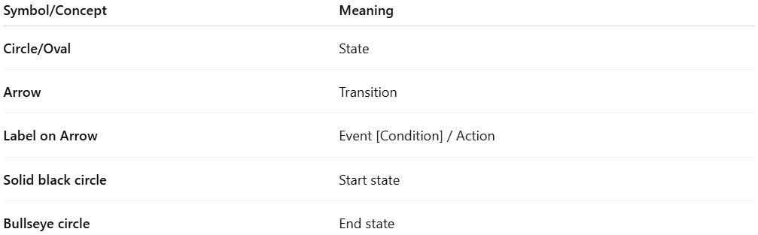
Symbol/Concept | Meaning
Circle/Oval | State
Arrow | Transition
Label on Arrow | Event [Condition] / Action
Solid black circle | Start state
Bullseye circle | End state

Example – ATM Withdrawal
# Source: Chatgpt (GPT-5-Standard) at [8/15/2025]
Let’s model a cash withdrawal process.
States:
- Idle
- Card Inserted
- PIN Entered
- Transaction Selected
- Cash Dispensed
Transitions:
- Idle → Card Inserted: Event = Insert Card
- Card Inserted → PIN Entered: Event = Enter PIN (valid)
- PIN Entered → Transaction Selected: Event = Select Withdrawal
- Transaction Selected → Cash Dispensed: Event = Amount Available
- Cash Dispensed → Idle: Event = Card Removed
Diagram flow (simplified):
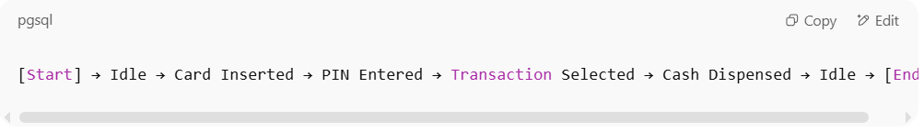
[Start] → Idle → Card Inserted → PIN Entered → Transaction Selected → Cash Dispensed → Idle → [End]

How it’s used in testing
# Source: Chatgpt (GPT-5-Standard) at [8/15/2025]
In State Transition Testing, the diagram helps testers:
- Identify valid transitions (to confirm system works when moving between states).
- Identify invalid transitions (to confirm the system blocks impossible moves).
- Design test cases that cover all states and transitions.

Benefits
# Source: Chatgpt (GPT-5-Standard) at [8/15/2025]
✅ Helps understand system behavior over time.
✅ Makes missing states or invalid transitions easier to spot.
✅ Supports boundary and negative testing by including illegal paths.

Example
# Source: Chatgpt (GPT-5-Standard) at [8/15/2025]
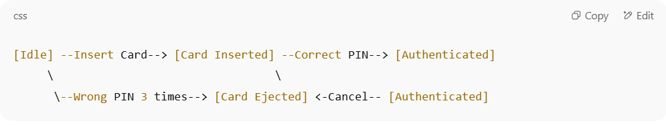
[Idle] --Insert Card--> [Card Inserted] --Correct PIN--> [Authenticated]
\ \
\--Wrong PIN 3 times--> [Card Ejected] <-Cancel-- [Authenticated]

State Matrix (State Table)
# Source: Chatgpt (GPT-5-Standard) at [8/15/2025]
A State Matrix (also called a State Transition Table) is a tabular way of representing the same information you’d see in a State Transition Diagram, but in a more structured, spreadsheet-like format.
Instead of a visual diagram with arrows, the matrix shows:
- Current State → Where the system is now.
- Event/Condition → What happens to trigger a change.
- Next State → Where the system will go after the event.
- Action → What the system does when the change happens.

1️⃣ Structure of a State Matrix
# Source: Chatgpt (GPT-5-Standard) at [8/15/2025]
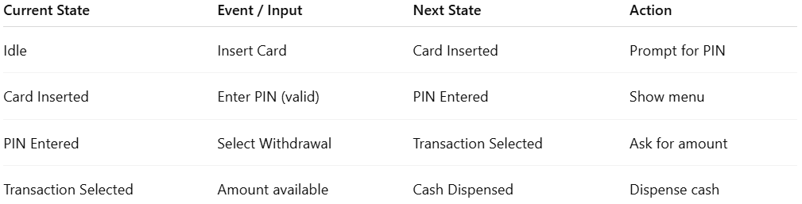
Current State | Event / Input | Next State | Action
Idle | Insert Card | Card Inserted | Prompt for PIN
Card Inserted | Enter PIN (valid) | PIN Entered | Show menu
PIN Entered | Select Withdrawal | Transaction Selected | Ask for amount
Transaction Selected | Amount available | Cash Dispensed | Dispense cash

2️⃣ Example – Simple Turnstile
# Source: Chatgpt (GPT-5-Standard) at [8/15/2025]
States: Locked, Unlocked
Events: Coin inserted, Push gate
Actions: Unlock gate, Lock gate, Alarm
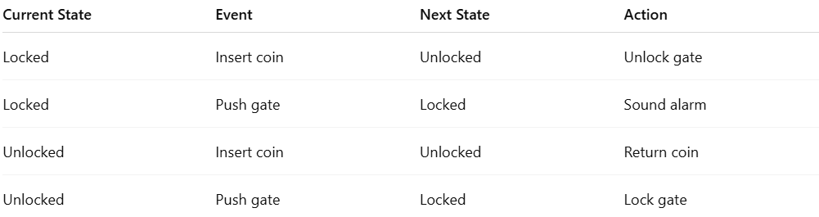
Current State | Event | Next State | Action
Locked | Insert coin | Unlocked | Unlock gate
Locked | Push gate | Locked | Sound alarm
Unlocked | Insert coin | Unlocked | Return coin
Unlocked | Push gate | Locked | Lock gate

3️⃣ Difference from State Transition Diagram
# Source: Chatgpt (GPT-5-Standard) at [8/15/2025]
- State Matrix = good for precise documentation and covering all event-state combinations (including invalid ones).
- State Diagram = better for visual understanding of flow.

Testing with State Transition Technique
# Source: Chatgpt (GPT-5-Standard) at [8/15/2025]
You design tests to cover:
- Valid transitions (expected paths)
- Invalid transitions (events not allowed in a state)
Example Test Cases:
- Idle → Insert Card → Card Inserted (valid)
- Card Inserted → Enter correct PIN → Authenticated (valid)
- Card Inserted → Withdraw money (invalid – should be blocked)
- Authenticated → Press cancel → Card Ejected (valid)

When to use State Transition Testing
# Source: Chatgpt (GPT-5-Standard) at [8/15/2025]
✅ Systems where order of events matters
✅ Systems with finite, well-defined states
✅ Examples:
- ATMs
- Elevators
- Online shopping checkout flows
- Traffic lights

Coverage
# Source: Chatgpt (GPT-5-Standard) at [9/13/2025]
State Transition Testing Coverage refers to how thoroughly your test cases exercise the states and transitions in a state machine model (state diagram or state table).
There are three main coverage criteria (as described in the syllabus):
Got it 👍 Let’s go through State Transition Testing Coverage again, step by step — clear and structured:

🔹 1. All States Coverage
- Definition: Every state in the model must be visited by at least one test case.
- Goal: Ensure that all states can be reached.
- Strength: Weakest coverage type.
- Formula:
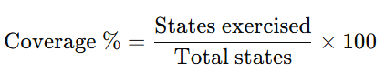
Coverage %=States exercisedTotal states×100\text{Coverage \%} = \frac{\text{States exercised}}{\text{Total states}} \times 100

🔹 2. Valid Transitions Coverage (0-Switch Coverage)
- Definition: Every valid transition (allowed movement from one state to another) must be executed by at least one test case.
- Goal: Ensure the system moves correctly between states.
- Strength: Stronger than state coverage.
- Bonus: Achieving this also guarantees All States Coverage.
- Formula:
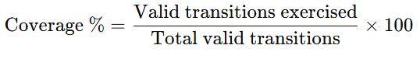
Coverage %=Valid transitions exercisedTotal valid transitions×100\text{Coverage \%} = \frac{\text{Valid transitions exercised}}{\text{Total valid transitions}} \times 100

🔹 3. All Transitions Coverage
- Definition: Every valid transition must be executed, and every invalid transition must be attempted.
- Goal: Ensure the system correctly handles valid and invalid movements.
- Strength: Strongest coverage type.
- Note: Especially required in safety-critical systems.
- Formula:
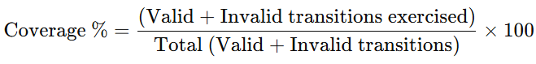
Coverage %=(Valid + Invalid transitions exercised)Total (Valid + Invalid transitions)×100\text{Coverage \%} = \frac{\text{(Valid + Invalid transitions exercised)}}{\text{Total (Valid + Invalid transitions)}} \times 100

✅ Comparison of Strength:
- All States Coverage → weakest.
- Valid Transitions Coverage → stronger, includes state coverage.
- All Transitions Coverage → strongest, includes both states + valid transitions.

Would you like me to now draw a simple state machine example (like ATM card states: Inserted → Valid → Ejected) and show test cases that achieve each coverage type?

